OOP Typing Race Simulator Part 1 Report
Task 1:
How encapsulation safeguards data
Encapsulation stops data from being accessed directly to prevent unintended changes and unauthorized modifications to data. By setting all the variables to private, the variables can only be accessed from within (getter and setter) methods inside the class – meaning that they can only be modified in the intended way set by the developer.
The accessor methods are:
getAccuracy
getProgress
getName
getSymbol
getBurnoutTurnsRemaining
isBurntOut

The mutator methods are:
burnOut
recoverFromBurnOut
resetToStart
typeCharacter
slideBack
setAccuracy
setSymbol

slideBack validation logic:
If the calculated new progress is below 0 (calculated by doing progress – given number of characters), then it sets the progress to 0. A progress of below zero should not be possible because the player should not be able to go further back than the starting line.
Otherwise, it is not negative, so it sets the progress equal to the new progress
setAccuracy validation logic:
If the given new accuracy is below 0 then it sets the player’s accuracy to 0.
If the given new accuracy is above 1 then it sets the player’s accuracy to 1.
If none of those conditions are met, then it sets the player’s accuracy to the given new accuracy.
The accuracy must be between 0 and 1 because an accuracy of 0 represents 0% and an accuracy of 1 represents 100% – it should not be possible to have an accuracy rating outside of these bounds.

These methods ensure that the data can only be placed within appropriate boundaries – and encapsulation ensures that the data can only be accessed through these methods, thus overall ensuring that the data cannot fall outside the intended boundaries.

Testing Evidence:
After running the typeCharacter() command three times, the progress went up to 3 (from 0).
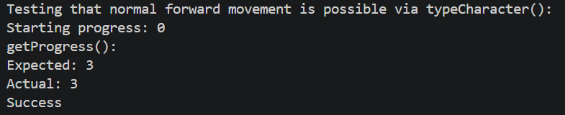

Calling slideBack(5), the program only reset the progress to 0.
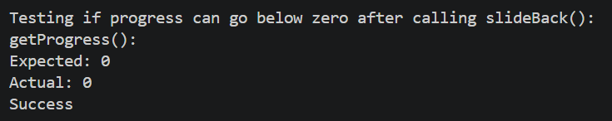
Calling burnOut(2) and recoverFromBurnout():
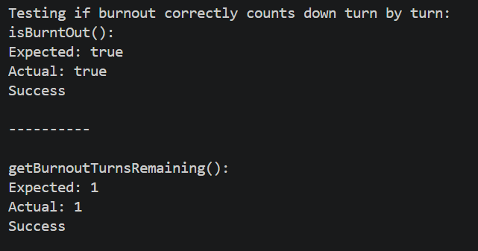

Continuing from the last test where the number of burnout turns remaining is 1, I ran this command recoverFromBurnout() to reset the number of burnout terms to 0.
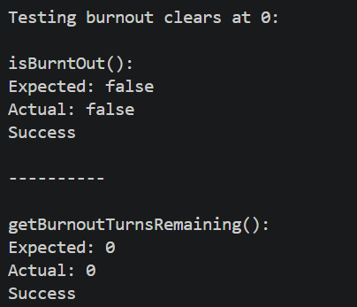

I ran typeCharacter() once as well as burnOut(1) to make the progress and burnout turns not zero before reset (to check that the reset actually works):
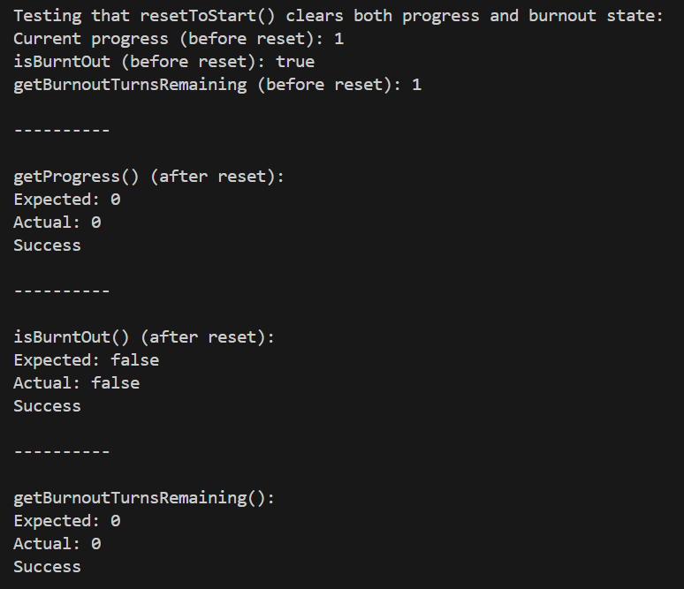

I ran setAccuracy(-0.3) before testing the first case, since -0.3 is below 0.0, and then ran setAccuracy(1.7) before testing the second case since 1.7 is above 1.0
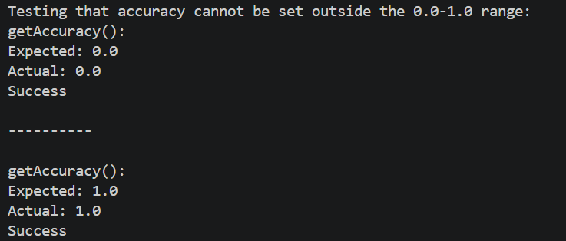

Task 2:
Errors:
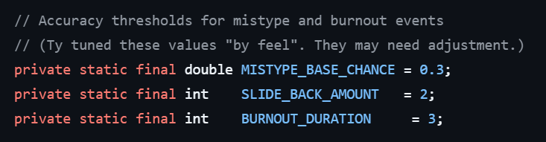
The mistype base chance seems to be okay. In the screenshot from the specification, it seemed like “QWERTY_QUEEN” slided back 2 spaces after mistyping so I will keep the slide back amount to 2. Furthermore, I decreased the burnout duration to 2 since in the screenshot from the specification, “HUNT_N_PECK” is burnt out for 2 turns.
My code:
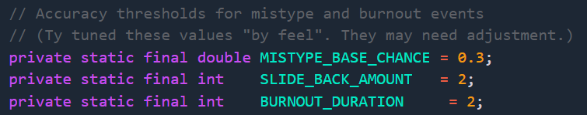

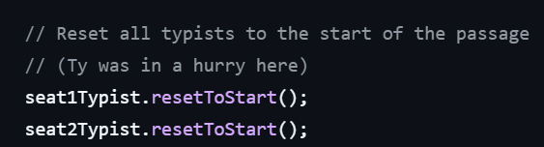
He didn’t reset seat3Typist.
My code:
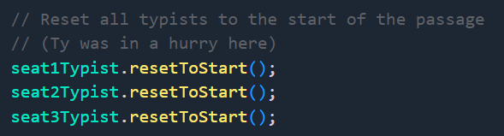


He didn’t print the winner’s name.
My code:
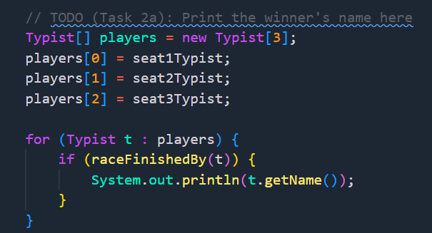
I put all the typists into an array, and cycle through them. Then, for each one I check if they have finished the race. If they have, I print their name. Since this code only runs when the race is finished, and since there can only be one winner, this code will print exactly one winner when run.

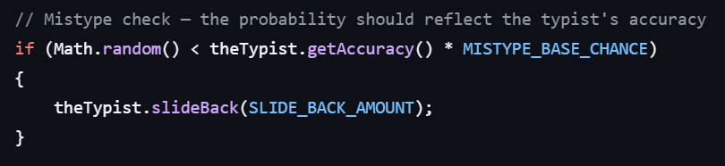
Math.random, theTypist.getAccuracy() and MISTYPE_BASE_CHANCE are all numbers between 0 and 1.
This is not the correct logic. If we say (theTypist.getAccuracy()*MISTYPE_BASE_CHANCE) = a, then we can say the operation is:
If (Math.random() < a) then a mistype happens.
Abstracting the specific syntax, we can say a = accuracy * base_chance.
On the operation (Math.random() < a), if take some examples we can see the relationship if a is higher or lower:
e.g. a = 0.288 and Math.random() = 0.5, then it’s (0.5<0.288).
e.g. a=0.24 and Math.random() = 0.5, then it’s (0.5<0.240).
When a is bigger, (Math.random() < a) is more likely to be true. This is because there are more numbers between 0 and 0.288 than there are numbers between 0 and 0.240, therefore when a is bigger, (Math.random() < a) is more likely to be true. When that is true, a mistype happens. Therefore we want that to be more likely to be true when the accuracy is lower.
However, if we look at how a is calculated, it is the opposite:
a = accuracy*base_chance.
If we take base_chance as 0.3 (since I have left it as that for now), and take these examples:
Accuracy = 0.96, then a = 0.96 * 0.3 = 0.288
Accuracy = 0.8, then a = 0.8 * 0.3 = 0.240
When the accuracy was higher, a was higher. When a is higher, the chance of a mistype happening is higher. Therefore, when accuracy is higher, with our current logic, the chance of a mistype is higher. But we want the opposite, if the accuracy is higher, then the chance of a mistype should be lower.
This can be changed if we change accuracy to (1-accuracy).
Testing these out with example values:
Accuracy = 0.96 therefore (1-accuracy) = 0.04, so 0.04*0.3=0.012
Accuracy = 0.8 therefore (1-accuracy) = 0.2, so 0.2*0.3=0.060
Therefore, when accuracy is higher, a is lower, so mistype chance is lower.
But, the chance of a random number between 0 and 1 being lower than 0.06 is still pretty unlikely. Therefore we need to change the base chance.
Testing out when base chance = 0.8:
(1-0.96)*0.8 = 0.032
(1-0.8)*0.8 = 0.360
These are reasonable values in my opinion, therefore I will also chance the mistype base chance to 0.8.
My code:
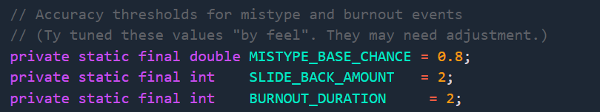
(MISTYPE_BASE_CHANCE was previously 0.3)
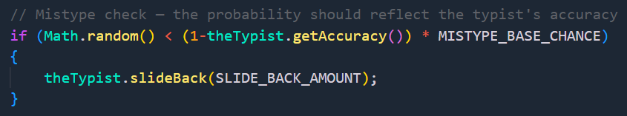

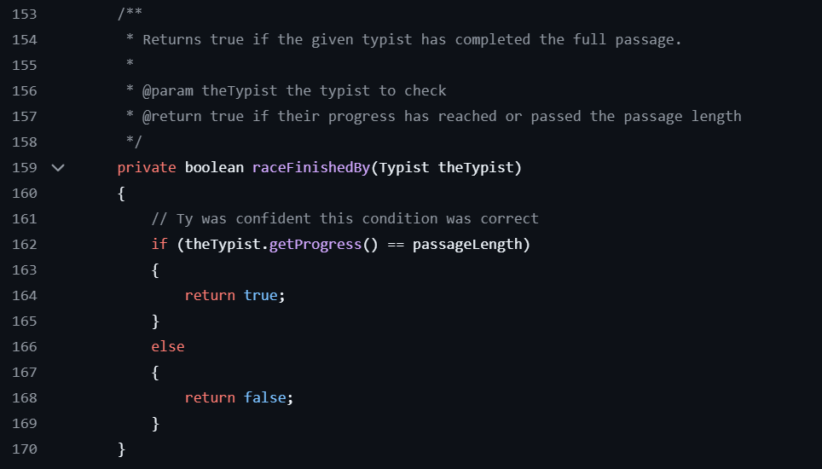
The comment says that it returns true if the typist’s progress has reached or passed the passage length, but the condition only checks if they have reached the passage length, not passed.
Therefore, I have modified the code:
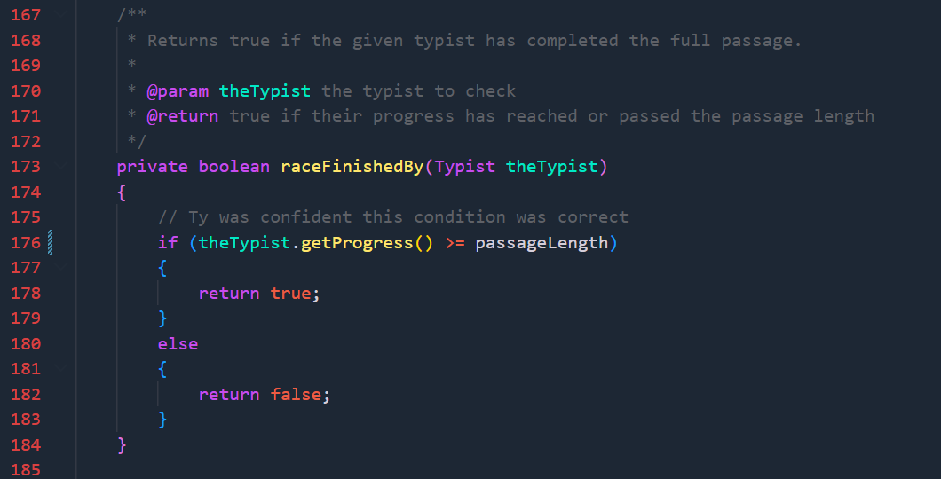

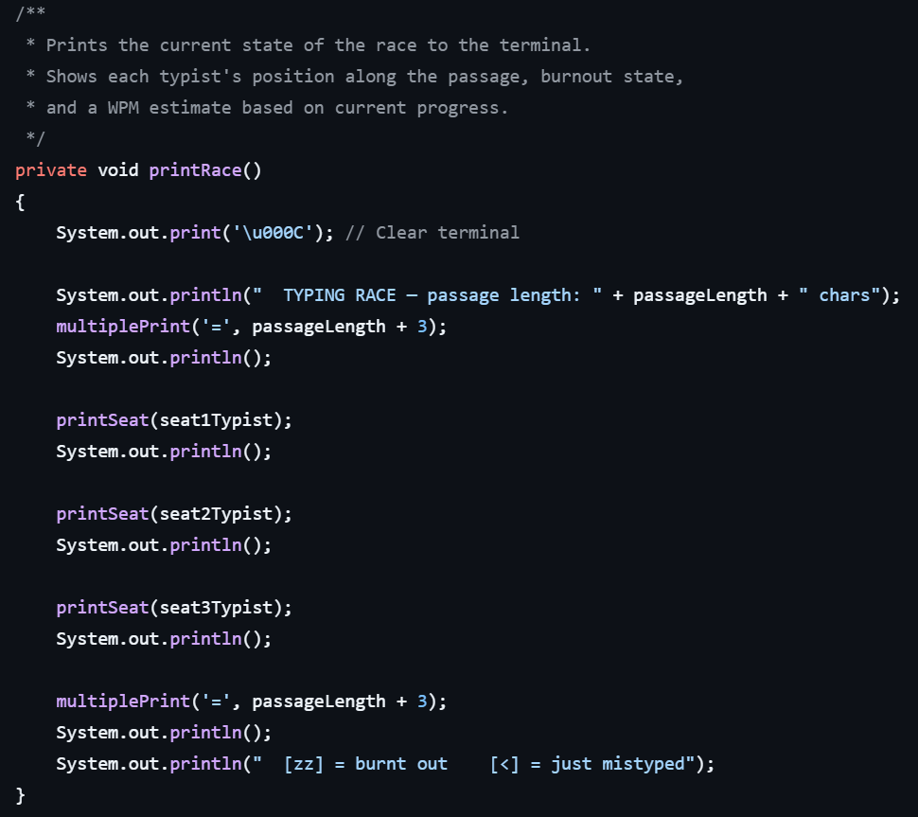
In the screenshot shown in the specification, the burnt out logo is a tilde.
Also, in the screenshot, the number of equals is 2 more than the passage length, not 3.
My code:
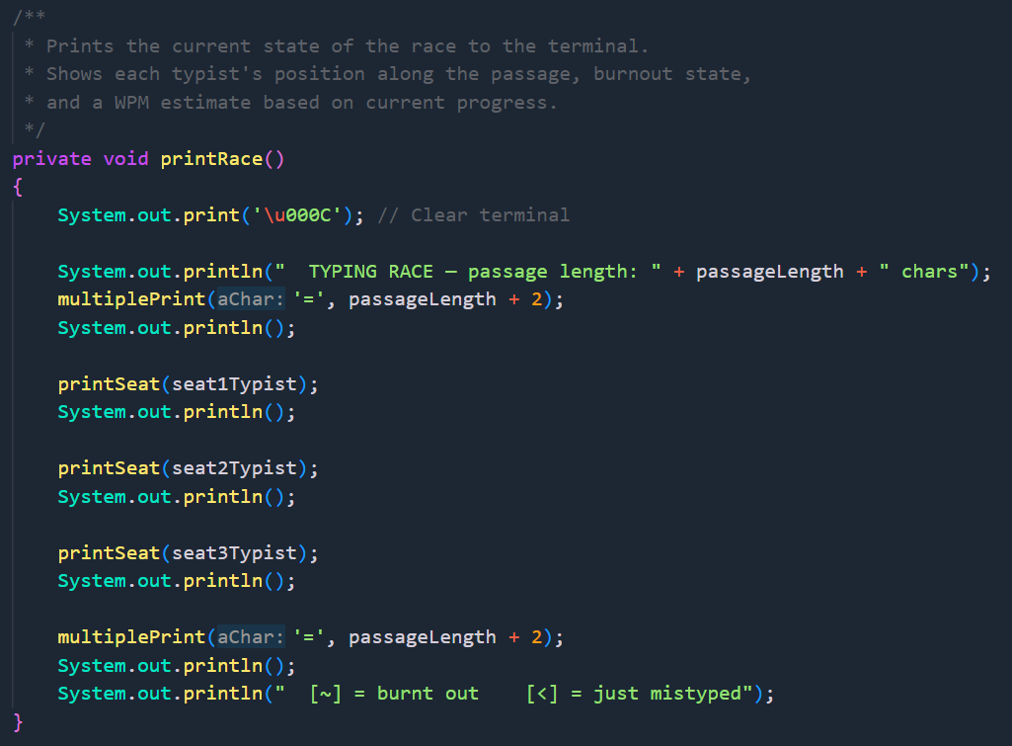

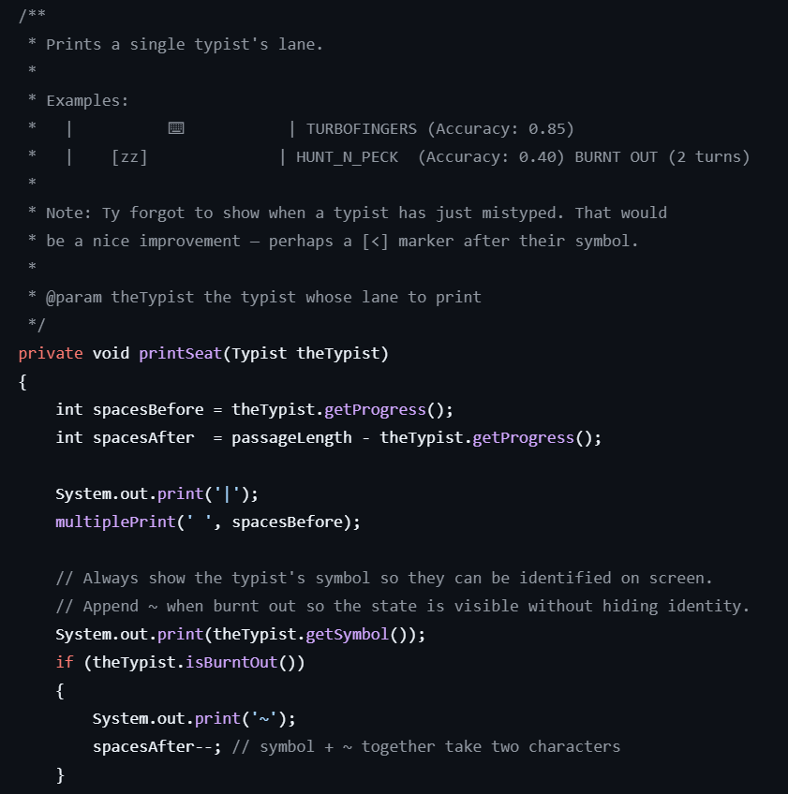
Firstly, the comment says that the symbol + ~ together take 2 characters but the code subtracts only 1 from spacesAfter. So I modified the comment.
Currently there is no way to check if the typist has just mistyped, so I need to add that.
I added a new attribute to the Typist class – justMistyped:
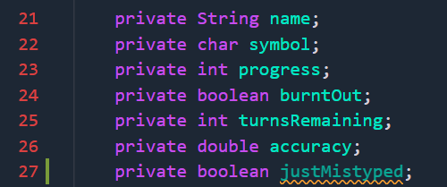
I added a hasJustMistyped method:
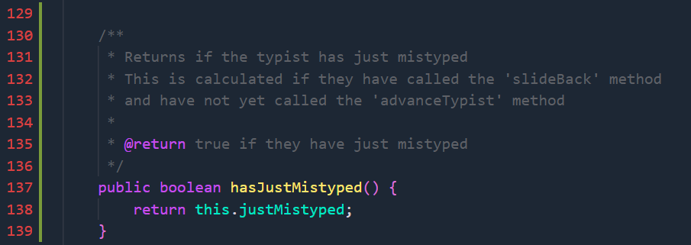

This returns the status of whether the typist has just mistyped.
However, I will need to also reset this value when the typists are reset:
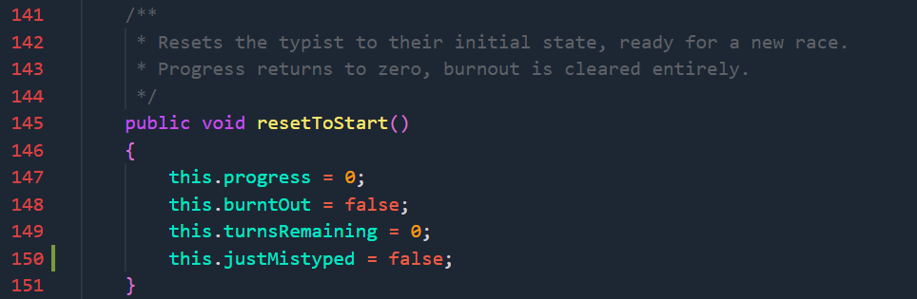
If the user mistypes (so if the slideBack method is called) then ‘justMistyped’ should be set to true:
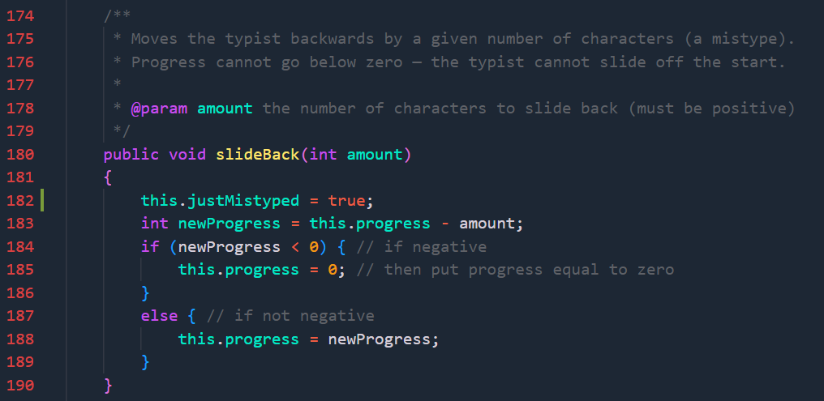
However, when they type normally again (when the advanceTypist method is called), then the value should be reset (set to false). Since advanceTypist is in the TypingRace class, it cannot access the justMistyped attribute directly, therefore I will need to create a method to reset the value to false.
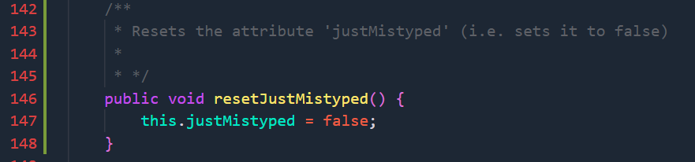
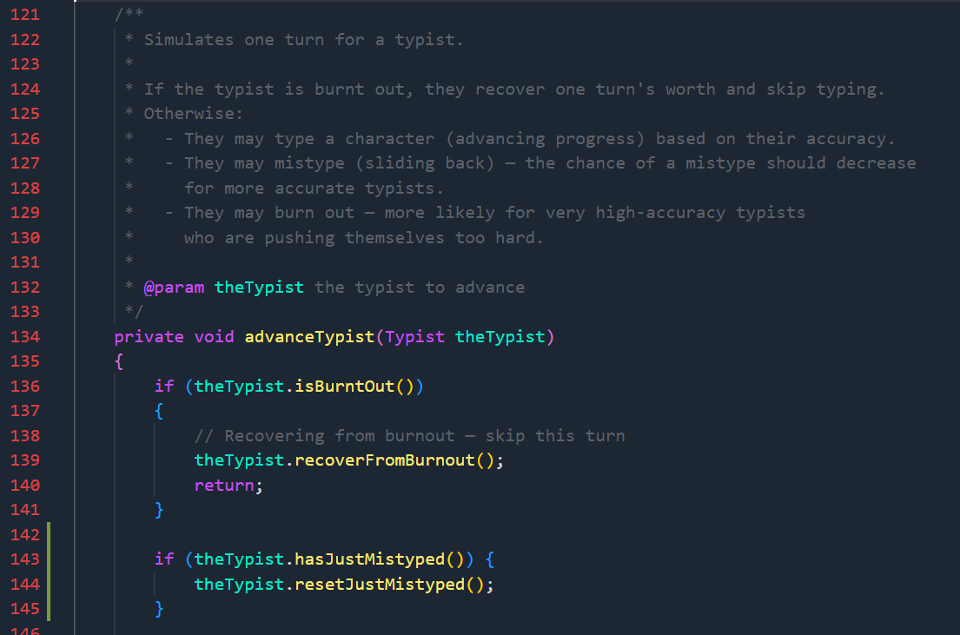
Now that I have made it clear if the typist has just mistyped, I need to set the symbol that they just mistyped, if they mistype.
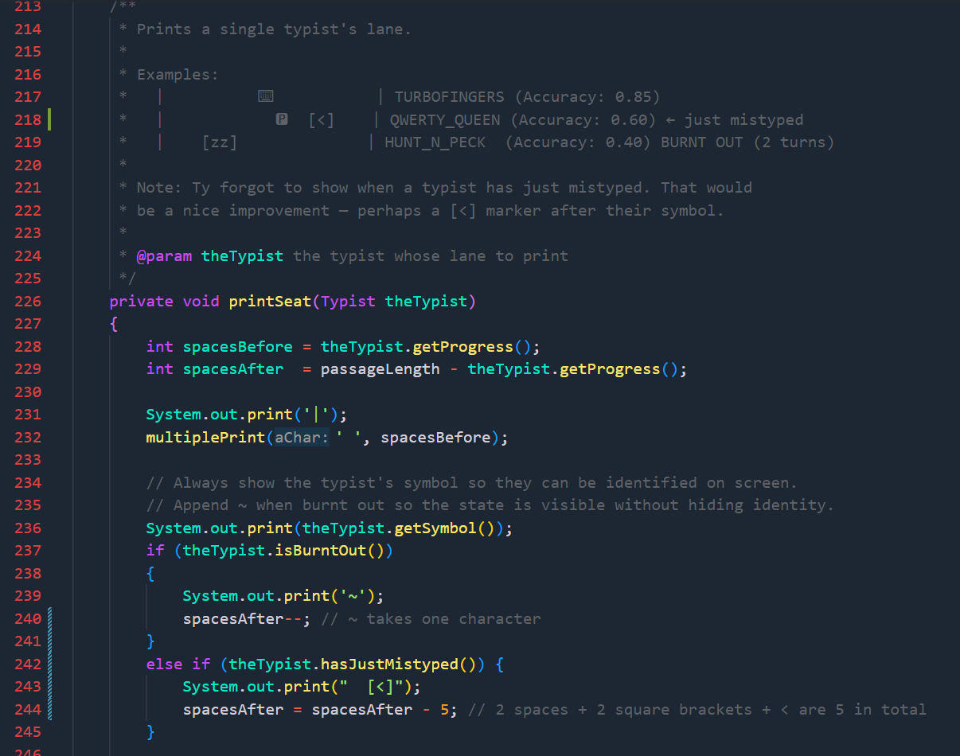
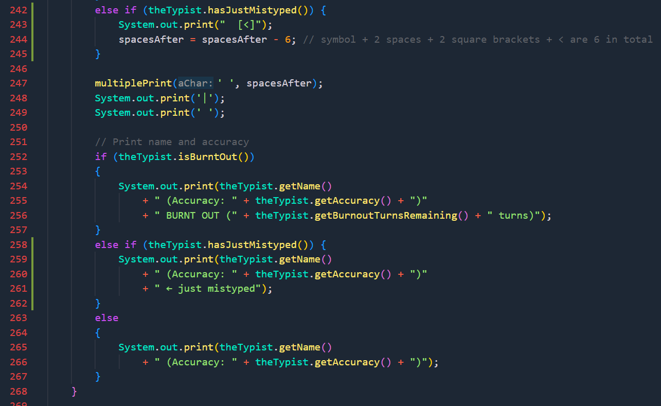

I implemented the performance adjustment – where a typist burning out slightly decreases their accuracy, and a typist winning a race slightly increases their accuracy. However, the program represents the accuracy to a very high number of decimal places:
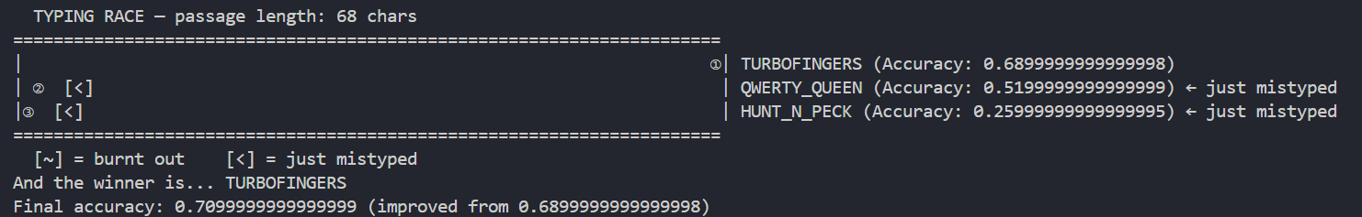
So I have decided to use the DecimalFormat subclass to format the accuracy to 2 decimal places.
I imported the subclass at the top of TypingRace.java:
And I created a new object of it at the beginning of the class so that it can be used throughout without having to define it everytime:
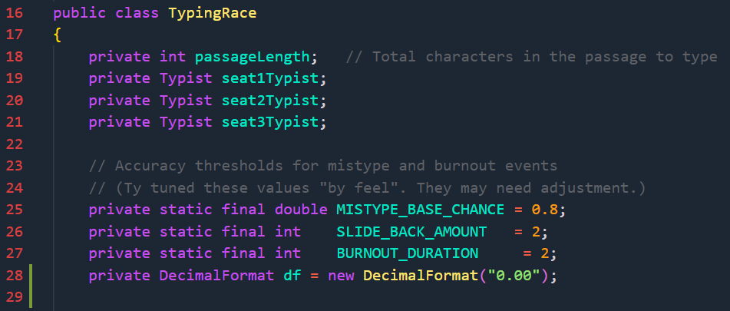
I then use it when printing the accuracy:
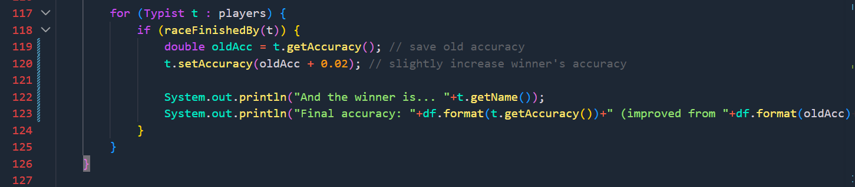
But I do not round for calculations as this could lead to inaccurate calculations.
